**EKITI STATE UNIVERSITY**

**P.M.B 5353, ADO-EKITI, EKITI STATE**

**DEPARTMENT OF COMPUTER SCIENCE**

**SIX MONTHS REPORT ON STUDENT INDUSTRIAL WORK**

**EXPERIENCE SCHEME (SIWES)**

**AT**

**TOLTEM INTERNATIONAL LIMITED**

**FLAT3, PLOT6, BESIDE TAKAWAY EATRY, ADAMOLEKUN ESTATE**

**ADO - EKITI.**

**AJAYI TEMILOLA ROSELINE**

**158862044**

**SIWES SUPERVISOR:**

**PROF AYAN ADELEKE**

**JANUARY, 2018.**

*IN PARTIAL FULFILLMENT OF THE REQUIREMENT FOR*

**THE AWARD OF BACHELOR OF SCIENCE (B.Sc)**

**DEDICATION**

I dedicate this report first and foremost to Almighty God who has been there right from the beginning to this very point. Special dedication also to my ever supportive parents Mr. Ajayi (Late) and Mrs. Ajayi for their advice, love, care and financial assistance have made me to be where I am today, I pray that the good lord will continue to keep and guide her for me, Amen.

**AKNOWLEDGEMENT**

With a deep sense of appreciation, respect and gratitude, I want to say a big thank you to my parent, brothers, sisters and other relatives and non-relative friends Most especially Ajayi Tioluwalase , for their caring attitude and support during my six month industrial training.

I also want to express my appreciation to my immediate supervisor, PROF AYAN ADELEKE for his intellectual support during my six month industrial training.

Not forgetting the other ICT Department Management team of Engr Arowolo Ifedayo, Barrister Femi Familusi, Engr Kamil Balogun and my other IT colleagues.

My sincere appreciation also goes to everyone that has been by me all this while.

**TABLE OF CONTENT**

**Title…………………………………………………………………..Page**

Cover Page………………………………………………………………1

Dedication ………………………………………………………………2

Acknowledgement………………………………………………………3

Table of Contents ……………………………………………………….4

**CHAPTER ONE**

**Introduction ……………………………………………………………..6**

Definition of SIWES ……………………………………………………**.**6

Purpose of SIWES ……………………………………………………...7

Aim and Objectives of SIWES …………………………………………7

**CHAPTER TWO**

**Brief Description of Place of Attachment …………………………....8**

Organizational Chart of the Place of Attachment ……………………...9

The Different Units in the Organization Chart………………………...10

Explanation of the different units in the organization chart …………...11

**CHAPTER THREE**

**Working Experience ……………………………………………………13**

Definition of terms………………………….…………………………….....14

HTML and its properties………………………………………………….…...16

Website design using HTML…………………………………………….….....17

CSS and its properties…………………………………………………….…...18

Website design using CSS……………………………………………….….....20

JavaScript and its properties………………………………………………......22

JavaScript work using HTML, CSS and JavaScript…………………………..23

CorelDraw Design…………………………………………………………24

Description of its part………………………………………………………25

Logo design using CorelDraw……………………………………………….26

Different Projects carried out ……………………………………………….27

Skills and knowledge acquired at the end of the projects……………………28

**CHAPTER FOUR**

**Problems Encountered…………………………………………………29**

Possible Solutions Proffered……………………………………………..30

**CHAPTER FIVE:**

**Recommendations and Conclusion………………………………………31**

Conclusion …………………………….…………………………………….31

Recommendations ……………………………………………………………31

**CHAPTER ONE**

**INTRODUCTION**

The student industrial work experience scheme (SIWES) popularly called Industrial Training (IT) by Nigerian Student is a yearly program design by the institution in collaboration with the industrial to give student the opportunity to gain practical working experience in their various field of study or area of specialization. It is an effect to bridge the existing gap between classroom theories and practical’s in engineering, management and other professional programs in the Nigerian tertiary institution.

Training is a key factor in changing expertise of a workforce. The world is passing through one of the worst economic crisis in recent time. Both the developed and developing economics are experiencing serious economic downturns.

It is through this Industrial Training that the educational system aims at helping student acquire appropriate skills, abilities and competencies, both mental and physical, as well as equip the individual live in society.

**DEFINITION OF SIWES**

Since the aim of our national policy in education is to build a strong and self- reliant nation, from the government’s decree No.47 of 8t h October, 1971 as amended in1990, which led to the establishment of Industrial Training Fund (ITF) in 1973/1974 and through the formation of this body (ITF), in the year 1993/1994 and through the formation of this body (ITF), in the year 1993/1974 SIWES was formed. In Nigeria, the current form of Cooperative Education is known as the Students Industrial Work Experience Scheme (SIWES).

The St9udents Industrial Work Experience Scheme (SIWES) is a planned and supervised training intervention based on stated and specific learning and career objectives and geared towards developing the occupational competencies of the participants. The aim is make education more relevance and also to bridge the science-related disciplines in tertiary institutions in Nigeria.

SIWES forms part of the approved minimum academic standards in the institutions, and is a core academic requirement carrying fifteen (15) credit units. This requirement must be met by all students in various disciplines before graduation.

**PURPOSE OF TRAINING**

The Scheme exposes students to industry based skills necessary for a smooth transition from the classroom to the world of work. It affords students of tertiary institutions the opportunity of being familiarized and exposed to the needed experience in handling machinery and equipment which are usually not available in the educational institutions.

One of the primary goals of the SIWES is to help students integrate leadership developmen9t into the experiential learning process. Students are expected to learn and develop basic non-profit leadership skills through a mentoring relationship with innovative non-profit leaders.

**AIMS AND OBJECTIVES OF SIWES**

* To provide an avenue for students in tertiary institutions to acquire industrial skills and experience in their course of study.
* To expose students to work methods and technique in handling equipment and machineries that may not be available in the institution.
* To prepare students for the work situation that they are likely to meet after graduation
* To provide students with the opportunity to apply their theoretical knowledge in real work situation, thereby bridging the gap between the university work and the actual work practices.
* To expose students to the latest developments and technological innovations their chosen professions.

**CHAPTER TWO**

**BRIEF HISTORY OF TOLTEM INTERNATIONAL LIMITED**

The establishment was called Toltem international limited, it is an information and communication technology company with broad expertise in ICT consultancy.

Toltem International Limited is a Nigerian based telecommunications and technology conglomerate in co-operated in 2016 and offering a wide range of automated and integrated solution in broad spectrum of computers and telecommunication technology.

Toltem is considered as one of the leading and fast growing ICT, Engineering and Project Management Company in Nigeria especially in the southwest region, with offices in Abuja, Ekiti, Akure, Owo, including the Head office in Ado - Ekiti, Ekiti State.

The company has been involved in several projects, ranging from building construction. They also involved in several projects, ranging from software design and development, internet connectivity.

Toltem realizes that the quality of employees and their development through training and education are major factors in determine long-term profitability of any business.

Therefore, there is ongoing training for new and current employees which helps them adjust to rapidly changing job requirements. We discover that our employees frequently develop a great sense of self-worth, dignity and well-being as they become more valuable to the firm and to society. Generally, they receive a greater share of the material gains that result from their increased productivity. These factors give them a sense of satisfaction through the achievement of personal and company goals.

**ORGANIZATIONALCHART OF TOLTEM INTERNATIONAL LIMITED**

Manager Director

Company Secretary

General Manager

Executive Director

Business Development Manager

Head, Civil & Structural Engr. (Consultant)

Project Architect (Consultant)

Business Development Officer

Strategic Mangt. And Business Process Consultant

Head ICT

Chief Software Architect/ Lead Developer.

Chief Technical Officer

Admin Officer

Associate Partner (Renewable Energy)

Senior Software

Lead Developer

Non-Executive Director

**THE DIFFERENT UNITS IN THE ORGANIZATION CHART**

* Managing Director
* Executive Director
* Non-Executive Director
* General Manager
* Senior Software/Lead Developer
* Chief Software Architect /Lead Developer.
* Head ICT
* Chief Technical Officer
* Strategic Mangt. And Business Process Consultant
* Business Development Manager
* Associate Partner (Renewable Energy)
* Head, Civil & Structural Engr. (Consultant)
* Project Architect (Consultant)
* Business Development Officer
* Admin Officer

**EXPLANATION OF THE DIFFERENT UNITS IN THE ORGANIZATION CHART**

Toltem is headed by a Board of Directors made up of both Executive and Non-Executive members with a Board Chairman in charge of the board, and Managing Director to assist the Board in its responsibilities of policy formulation which spans across all business interests of Toltem International Limited. The Management of Toltem under the leadership of the managing Director/CEO, who reports to either the Board of Directors or any of its Committees as the case may be, sees to the day-to-day running of the company. The highest decision making Committee at Management level is the Executive Committee made up of Executive Directors of Toltem. For smooth operations of the company, the office of the Managing Director is charge with the responsibility of regular examining the dynamic Corporate Organogram and making suggestions to the Board for its amendment to meet changing market and or functional needs. He/ She is also responsible for formation of management committees where membership cuts across the entire company. The Non-Executive Directors are responsible for overall supervision and guidance of the divisions under them and can also set up committee to harness the resources within their purview provided membership is from their directorate. The Executive Directors report to the Managing Director.

**CHAPTER THREE**

**WORKING EXPERIENCE**

During my six (6) months Student Industrial work Experience Scheme (SIWES) at Toltem International Limited, I was exposed to Web Development using Hypertext Mark-up Language (HTML), Cascading Style Sheet (CSS) and graphics design using CorelDraw.

**DEFINITION OF TERMS**

I was introduced to the following.

**WEBSITE:**

A website is a set of related webpages containing content such as texts, images, videos, audios, etc. A website is hosted on at least one web server, accessible via a network such as the internet or a private LAN through an internet address known as a URL (Universal Resource Locator). A publicly accessible websites collectively constitutes the World Wide Web (WWW).

**WEBPAGE:**

A webpage is a document, typically written in plain text interspersed with formatting instructions of hypertext markup language (HTML, XHTML). A webpage may incorporate elements from other websites with suitable anchors. Webpages are accessed and transported with the hypertext transfer protocol (HTTP), which may occasionally employ encryption (HTTP secure, HTTPS) to provide security and privacy for the use of the webpage content. The user’s application often a web browser renders the page content according to its HTML mark-up instructions into a display terminal.

**HTTP:**

This stands for Hyper Text Transfer Protocol which is the set of rules for transferring files (text, graphic, images, sound, video, and other multimedia files) on the World Wide Web.

**URL:**

This stands for Uniform Resource Locator and as the name suggests, it provides a way to locate a resource on the web, the hypertext system that operates over the internet.

**HTML AND ITS PROPERTIES**

HTML stands for **H**yper**t**ext **M**ark-up **L**anguage, and it is the most widely used language to write Web Pages.

* **Hypertext** refers to the way in which Web pages (HTML documents) are linked together. Thus, the link available on a webpage is called Hypertext.
* As its name suggests, HTML is a **Markup Language** which means you use HTML to simply "mark-up" a text document with tags that tell a Web browser how to structure it to display.

Originally, HTML was developed with the intent of defining the structure of documents like headings, paragraphs, lists, and so forth to facilitate the sharing of scientific information between researchers.

Now, HTML is being widely used to format web pages with the help of different tags available in HTML language.

|  |  |
| --- | --- |
| **Tag** | **Description** |
| <html> | This tag encloses the complete HTML document and mainly comprises of document header which is represented by <head>...</head> and document body which is represented by <body>...</body> tags. |
| <head> | This tag represents the document's header which can keep other HTML tags like <title>, <link>, <script language =”JavaScript”> etc. |
| <title> | The <title> tag is used inside the <head> tag to mention the document title. |
| <body> | This tag represents the document's body which keeps other HTML tags like <h1>, <div>, <p>, <table> etc. |
| <h1> | This tag represents a heading |
| <p> | This tag represents a paragraph. |
| <b>, <i>, <li>, <ul>,<ol> | Bold, italic, list, unordered list, ordered list |

**HTML TABLE:**

The HTML table model allows web designers to arrange data –text, preformatted text, images, links, forms, form fields, other tables, etc. into rows and columns of cells. It is defined with the <table> tag.

Tables are divided into table rows with the <tr> tag. Table rows are divided into table data with the <td> tag. A table row can also be divided into table headings with the <th> tag. Table data <td> are the data containers of the table. They can contain all sorts of HTML elements like text, images, lists, other tables

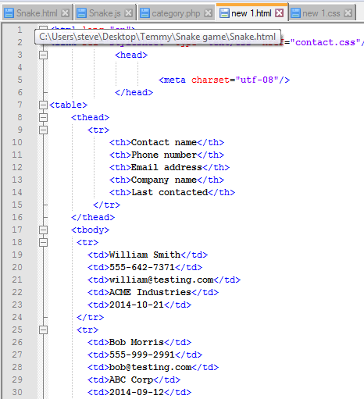**CODE VIEW**

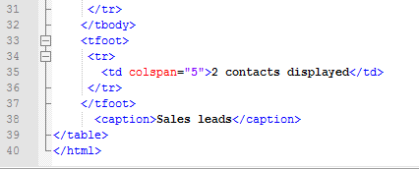

**DESIGN VIEW**

**CSS AND ITS PROPERTIES**

CSS stands for **C**ascading Style Sheet used for formatting html document. It is a style sheet language used for describing the presentation of a document written in a mark-up language.

**Note:** CSS code is not written the same way as HTML code is. This makes sense because CSS is not HTML, but rather a way of manipulating existing HTML.

**REASONS FOR CSS**

The following are reasons why CSS is better

1. It saves time
2. It eradicate the idea of using repeating codes
3. It provides efficiency in design and updates: with css, we are able to create rules, and apply those rules to many elements within the website.
4. It can lead to faster page downloads: since rules are only downloaded once by the browser, then are the cached and used for each page load, the use of css can lead to lighter page loads, and improved performance. This contributes to lighter server loads and lower requirements, which overall saves money for our clients.

5. It creates external file (server side) for managing html content

**METHOD USED BY CSS IN FORMATTING HTML DOCUMENT**

1. **Inline Style:** It is used to apply a unique style to a single HTML element. An inline CSS uses the style attribute of an HTML element.
2. **Embedded / Internal Style:** It is used if one single page has a unique style. Internal styles are defined within the <style> element, inside the <head> section of an HTML page
3. **External Style:** With an external style sheet, you can change the look of an entire website by changing just one file. Each page must include a reference to the external style sheet file inside the <link> element. The <link> element goes inside the <head> section. Also when using external CSS it is preferable to keep the css separate from your HTML. Placing CSS in a separate file allows the web designer to completely

Differentiate between content (HTML) and design (CSS). External CSS is a file that contains only CSS code and is saved with a “.css” file extension. This CSS is then referenced in your HTML using the <link> instead of <style> as earlier stated.

**CSS SELECTORS AND HOW THEY CAN BE USED**

CSS selectors are used to find or select HTML elements based on their element name, id or class

1. **Element Selector:** The element selector selects elements based on the element name.
2. **Id Selector:** The id selector uses the id attribute of an HTML element to select a specific element. The id of an element should be unique within a page, so the id selector is used to select one unique element. e.g. id=”hello” css #hello { color: red;}
3. **Class Selector:** The class selector selects elements with specific class attribute. To select elements with a specific class, write a period (.) character followed by the name of the class. e.g. .center {text-align: center;}

**CSS RULES OVERRIDING**

1. Any inline style sheet takes the highest priority, so it will override any rule defined in<style>……</style> tags.
2. Any rule defined in <style>………</style> tags will override the rules defined in any external style sheet file.

**CSS COMMENTS**

To simply put comment inside a style sheet you use /*………..*/, you can use it to comment multi- line blocks.

**BACKGROUND AND FONT OF VARIOUS HTML ELEMENTS**

You can set the following background properties of an element.

1. **The background-color:** Is a property used to set the color background of an element.
2. **The background-image property:** is used to set the background image of an element.
3. **The background repeat:** Is used to control the repetition of an image in the background.
4. **The background position:** Is used to control the position of an image in the background.
5. **The background attachment:** Is used to control the scrolling of an image in the background.
6. **The background property:** Is used as a short hand to specify a number of other background properties.

**FONT WHICH ARE;**

1. **The Font-family property:** This is used to change the face of a font
2. **The Font-style property:** This is used to make a font italic or oblique.
3. **The Font-weight property:** This is used to increase or decrease how bold or light a font appears.
4. **The Font-size property:** This is used to increase or decrease the size of a font.

**TEXT DECORATION:**

This demonstrate how to decorate a text in CSS, the values are none, underline, over line, line through and blink.

**CSS CODING VIEW**

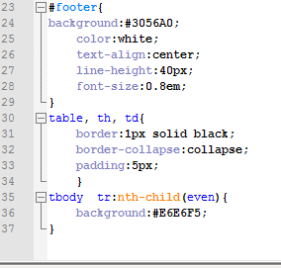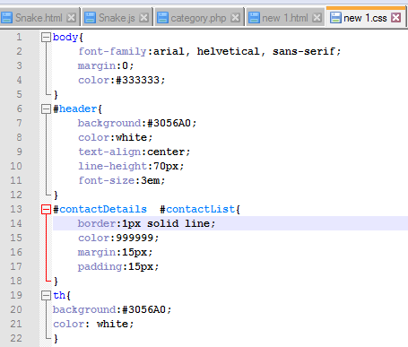

**DESIGN VIEW**

**JAVASCRIPT AND ITS PROPERTIES**

JavaScript is a dynamic computer programming language. It is lightweight and most commonly used as a part of web pages, whose implementations allows client side script to interact with the user and make dynamic pages. It is an interpreted programming language with object oriented capabilities. It was developed by Brenan Erich 1995-1996; it is an implementation of ECMA Script (European Computer Manufacturers Association). It was also known as livescript later change to JavaScript. It is use for client side web form validation. JavaScript cannot run with been embedded in the HTML.

**FUNCTIONS OF JAVASCRIPT**

1. It is most commonly used as a client side scripting language, which implies that JavaScript is written into an HTML page and when a user request an HTML page with JavaScript in it, the script is sent to the browser.
2. It used for form validation.

**JAVASCRIPT DEVELOPMENT TOOLS**

One of the major strengths of JavaScript is that it does not require expensive development tools. One can begin with a simple text editor such as notepad or notepad++. Since it is an interpreted language inside the context of a web browser, you don’t even need to buy a compiler.

However to make life simpler, various vendors have come up with very nice JavaScript editing tools, they are macromedia Dreamweaver.

**JAVASCRIPT SYNTAX**

JavaScript can be implemented using JavaScript statements that are placed within the <script>…………..</script> HTML tags in a web page. You can place the <script> tags, containing your JavaScript, anywhere within your web page, but it is normally recommended

That we should keep it within the <head> tags

**COMMENTS IN JAVASCRIPT**

JavaScript supports both c-style and C++ style comments. Thus:

1. Any text between a // and the end of a line is treated as a comment and is ignored by JavaScript.
2. Any text between the characters /* and */ is treated as a comment. This may span multiple lines.
3. JavaScript also recognizes the HTML comment opening sequence <!--. JavaScript treats this as a single- line comment, just as it dos the //comment.
4. The HTML comment closing sequence --!> is not recognized by JavaScript so it should be written as //-->

**HOW TO ENABLE JAVASCRIPT IN BROWSER**

1. Was taught that all the modern browsers come with built-in support for JavaScript. Frequently, we may need to enable or disable this support manually. The following procedure will help us to enable and disable JavaScript in our browsers.

**JAVASCRIPT IN GOOGLE CHROME**

Here are the steps to turn on JavaScript in Chrome:

* Click the Chrome menu at the top right hand corner of your browser.
* Select **Settings**.
* Click **Show advanced settings** at the end of the page.
* Under the **Privacy** section, click the Content settings button.
* In the “JavaScript” section “Allow any site to run to JavaScript.

**MY JAVASCRIPT PROGRAM TO OUTPUT MY NAME**

**CODE VIEW** **DESIGN VIEW**

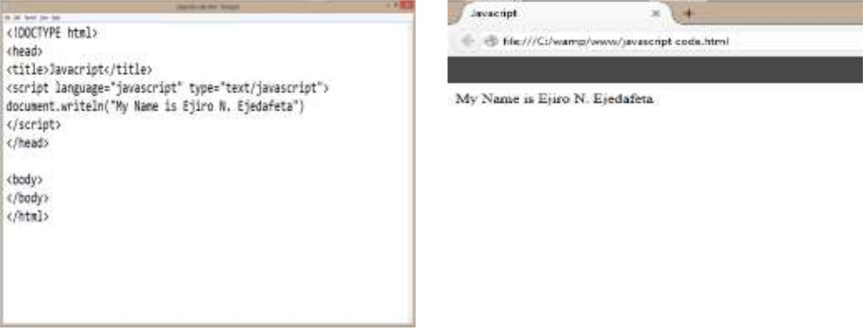

**GRAPHIC DESIGN**

Graphic Design is art with a purpose. It involves a creative and systematic plan to solve a problem or achieve certain objectives, with the use of images, symbols or even words. It is visual communication and problem solving through the use of typography, photography and illustration. The aesthetic expression of concepts and ideas using various graphics elements and tools.

**CorelDraw application window**

When I open CorelDraw, the application window open which contain a drawing window, it looks like rectangle in the center at the drawing window which is drawing page where I create my drawing

**Description of its Parts**

**Title bar:** The area displaying the title of the currently open drawing.

**Menu bar:** The area containing pull-down menu option.

**Toolbar (Standard):** A detachable bar that contains shortcuts to menu and other commands.

**Property Bar:** A detachable bar with commands that relate to the active tools or object. For example, when the text tool is active, the text property bar disblays commands that create and edit text.

**Drawing Window:** The area outside the drawing page bordered by the scroll bars and application controls.

**Drawing Page :** The rectangular area inside the drawing window. It is the printable area of your work area.

**Ruler:** horizontal and vertical borders that are used to determine the size and position of objects in the drawing.

**Document Navigator:** the area at the bottom left of the application window that contains controls for moving between pages and adding pages.

**Status Bar:** An area at the bottom of the application window that contains information about object properties such as type, fill, size, color and resolution. The status bar also shows the current mouse position.

**Navigator:** A button at the lower-right corner that opens a smaller display to help you move around a drawing

**Color Palette:** A dockable bar that contain color swatches.

**Docker:** A window containing available commands and settings relevant to a specific tools nor task.

**Different Projects carried out**

**CODE VIEW**

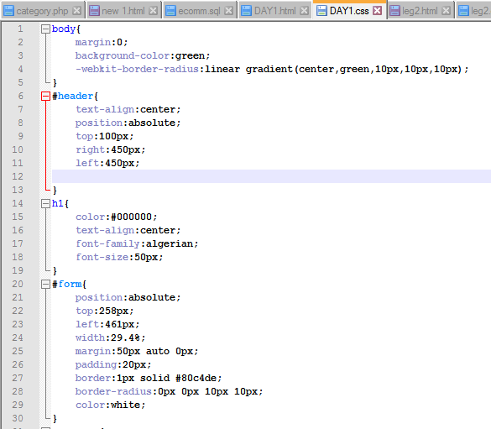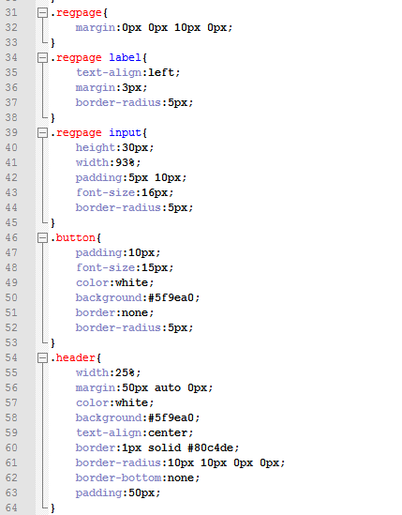 **CSS CODE**

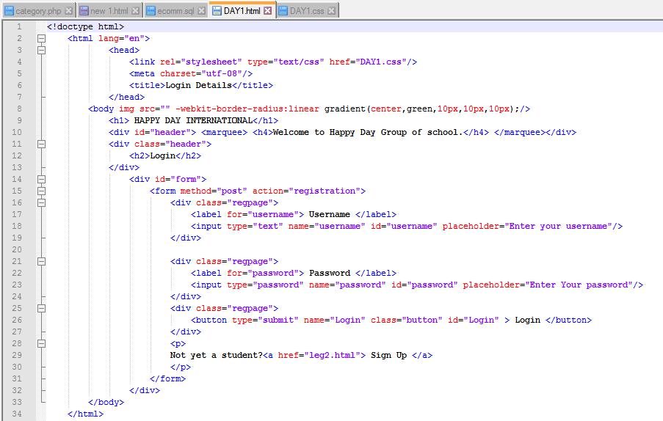**HTML CODE**

**DESIGN VIEW**

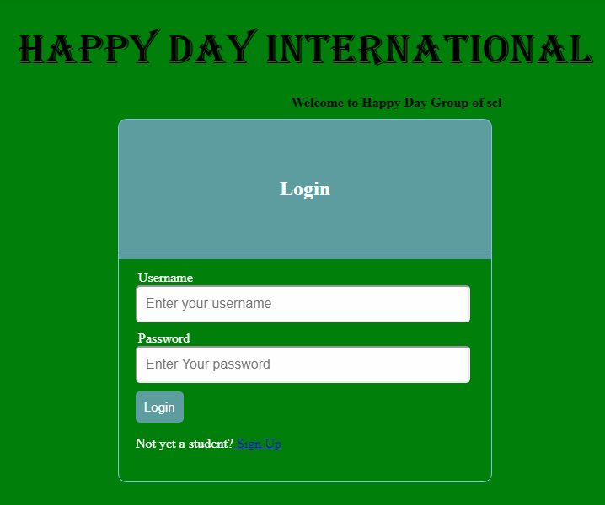

**GRAPHIC DESIGN WORK DONE**

These are some of the design project I worked on during my Industrial Training at Toltem International Limited, Using CorelDraw.

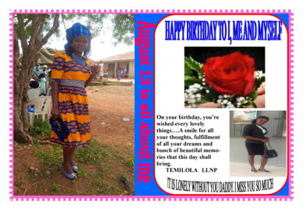

**TECHNICAL SKILLS AND KNOWLEDGE ACQUIRED**

Below are list of skills I acquired during my Industrial Training at TOLTEM INTERNATIONAL LIMITED

* Deep knowledge in understanding web design and database maintenance.
* Ability to create websites with the help of HTML and CSS.
* Debugging errors and been creative in arrangement of codes.
* Installing Database (Xampp) and linking PHP to the Database.
* Ability to Insert, Update, Select, Delete records in the Database and Importing,
* Exporting database file from one local server to another.
* Ability to create a standardize websites with the help of HTML, CSS, JAVASCRIPT, and PHP.
* Ability to install new window on a system

**CHAPTER FOUR**

**PROBLEMS ENCOUNTERED AT WORK PLACE**

* Difficulty in debugging some of my errors
* Difficulty in converting strings to object and vice versa (serialization and Deserialization).

**POSSIBLE SOLUTIONS PROFFERED**

* I am able to use Google web console with the help of my company tutor, I can use it to debug my error find in my code effectively.
* I am able to solve the problem through the uses of Reviver(optional second parameter)

**CHAPTER FIVE**

**RECOMMENDATIONS AND CONCLUSION**

**CONCLUSION**

My six (6) months Industrial Training at TOLTEM INTERNATIONAL LIMITED was a huge success and a great time of acquisition of knowledge and skills. Through my training I was able to appreciate my chosen course of study even more, because I had the opportunity to blend the theoretical knowledge acquired from school with the practical hands-on application of knowledge gained here to perform very important tasks that contributed in a way to my productivity in the company. My training here has given me a broader view to the importance and relevance of Computer Science (Web Design Development) in the immediate society and the world as a whole, as i now look forward to impacting it positively after graduation. I have also been able to improve my communication and presentation skills and thereby developed good relationship with my fellow colleagues at work. I have also been able to appreciate the connection between my course of study and other disciplines in producing a successful result.

**RECOMMENDATIONS**

* Schools should provide places of attachments for students.
* Allowances should be paid to students during their program just like NYSC and not after. This would help them a great deal to handle some financial problems during their training course.